Source ID: 79953199

Source Title: Dongli Gongcheng Xuebao/Journal of Chinese Society of Power Engineering

Current Issue URL: <https://jcspe.speri.com.cn/EN/current>

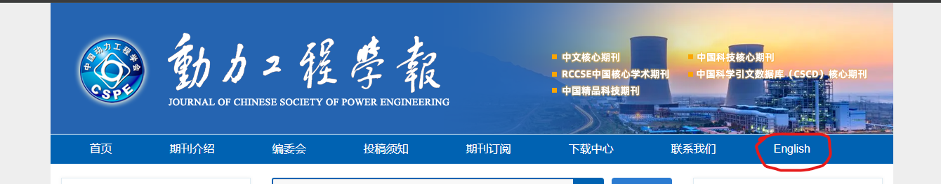

**Change language**

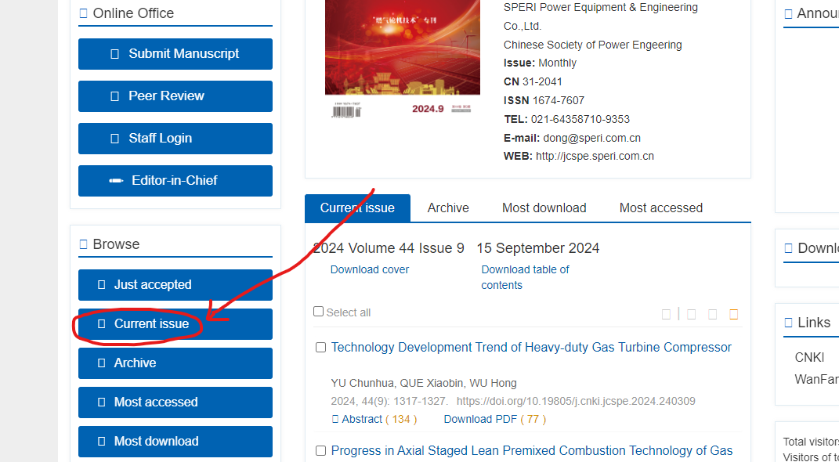

**After changing language, click here to access ‘Current Issue’**

**Both English & Chinese TOC need to merge to Template**

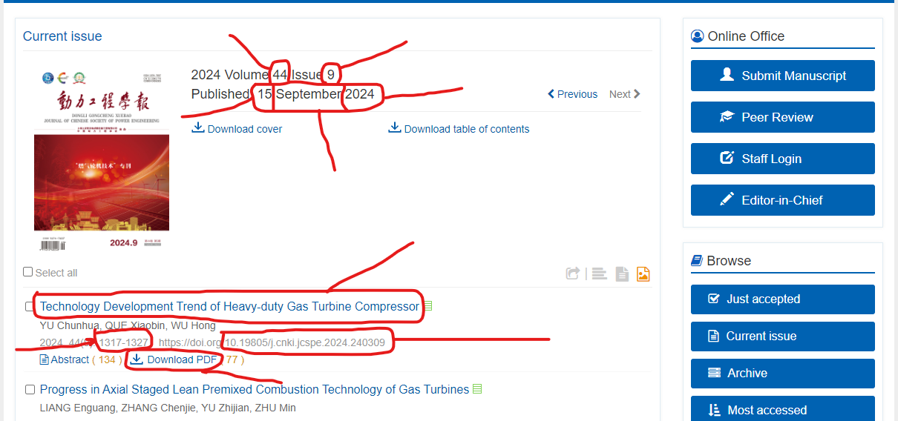

**Title**

**Date**

**Volume**

**DOI**

**PDF**

**Page Range**

**Month**

**Year**

**Issue**